News24- Election Survey

1.0 Introduction

1.1 Functional Requirements

News24 is a famous news channel in India. They had a plan to get rating from the people to know which party has majority chance for winning the election. For that they need a web application. Create a Spring MVC Spring Boot Application to achieve this task. Design a show Page to get ratings for the given parties. On clicking submit Survey button, the application should add the details into the list.

1.2. Use Case Diagram

View ratings
Get Ratings
Add rating

Actor

2.0 Technical Specifications

2.1 Process Flow
- The first page of the application is index.jsp page, this page should have hyperlinks to navigate showPage.jsp and viewReport.jsp

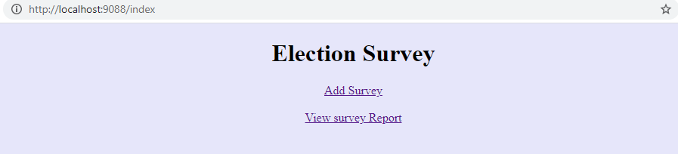
- In showPage.jsp, the page should have the below form components.
Component | Component Type | Component ID
Name | Textbox | name
emailId | Textbox | EmailId
Rating for BKJ | Drop down | ratingForBKJ
Rating for BKJ | Drop down | ratingForCFG
Rating for Others | Drop down | ratingForOthers
Submit | Submit | submit

- In the same page we have the provision to choose language English, German and French. By default, the page content will be displayed in English. If we choose the language as French the label content and the error message in the page should displayed in French and if we choose the language as German the label content and the error message in the page should displayed in German. Ensure you implement the concept of Internationalization.
- In the showPage.jsp page, ensure you use the component type and id correctly as specified in the above table.
- The values for component ratingForBJK, ratingForCFG and ratingForOthers drop-down should have the rating value 0-5. They should be hardcoded inside the JSP.
- SurveyService class contains the attribute surveyList with type as ArrayList<Survey>

- Sample showPage.jsp for displaying the page content in English
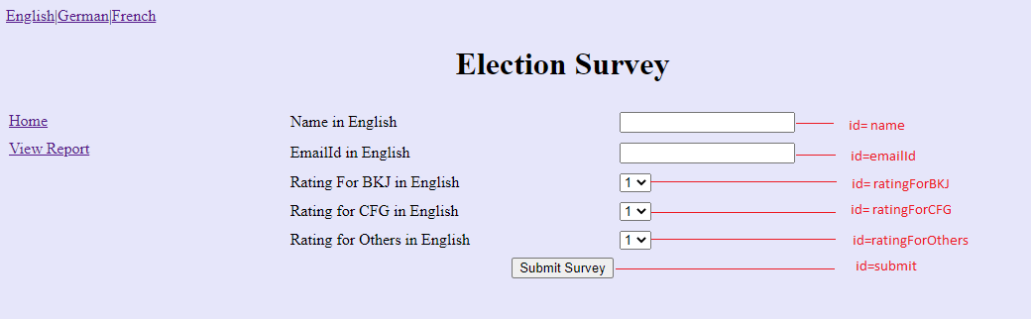

- Sample showPage.jsp for displaying the page content in German
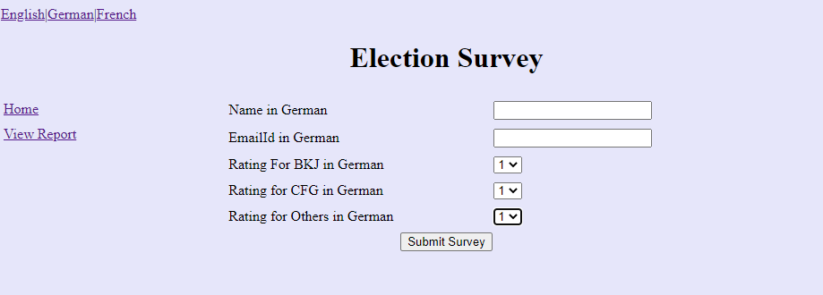

- Sample showPage.jsp for displaying the page content in French

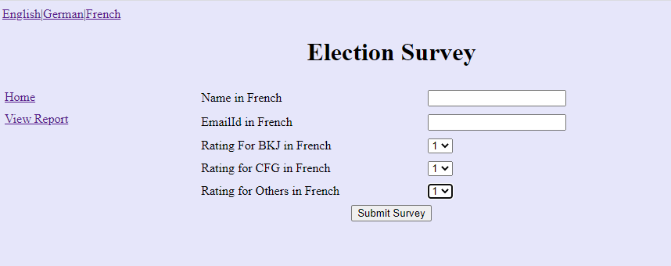

The submit survey button, on-click after all successful validations (Refer 2.2 for validation), invoke submitSurvey method of SurveyService class, here iterate the surveyList and confirm whether it has the survey object with same emailId, if not then add Survey object into the surveyList. Otherwise raise an InvalidSurveyException with the message “Sorry!! Already <<emailId>> have submitted the survey”. Handle this exception using ExceptionHandler and render the message in exceptionPage.jsp
showPage.jsp
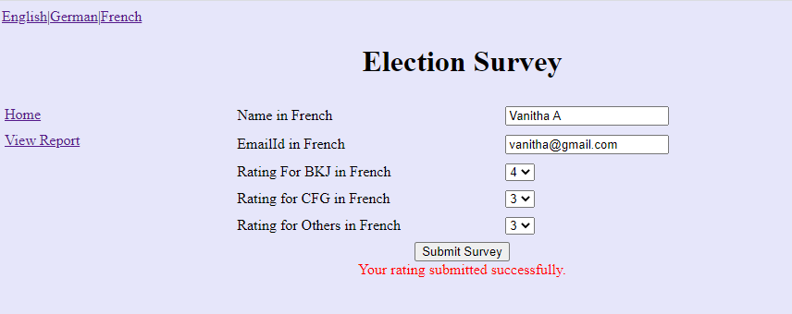
After adding the survey object into the surveyList, display the success message “Your rating submitted successfully.” in the div tag (refer the above screenshot). div tag with id as “message” is already available as part of code skeleton. While click on the hyper link Home, it should navigate to index.jsp. And for View Report hyper link , it should navigate to viewReport.jsp

- Render the survey list in the viewReport.jsp

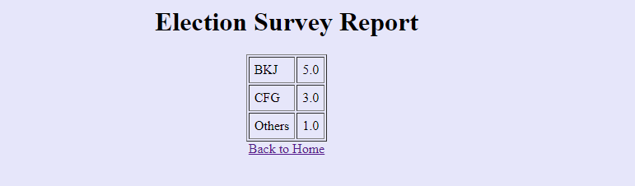
On clicking “Back to home” it should redirect to index.jsp page

exceptionPage.jsp (while adding survey details, if any duplicate emailId found then render the message in exceptionPage.jsp)
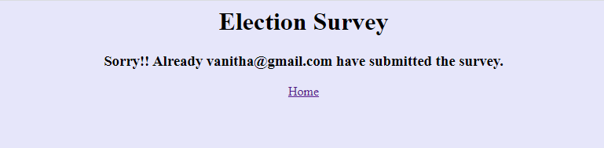
On clicking “Home” it should redirect to index.jsp page

2.2 Business Validation

- Rule: Name should not be blank
- Message: Required Name in <<locale>>
  - If validation fails, UI should display the error message - “Required Name in <<locale>>”.

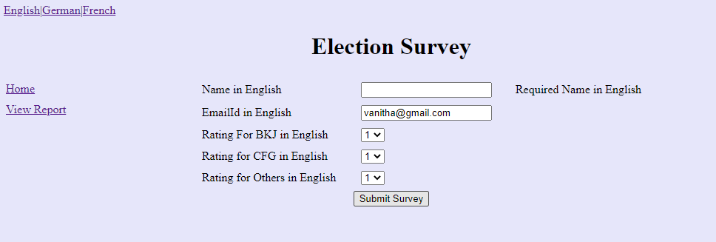

- Rule: EmailId should not be blank
- Message: Required EmailId <<locale>>
  - If validation fails, UI should display the error message - “Required EmailId in <<locale>>”.

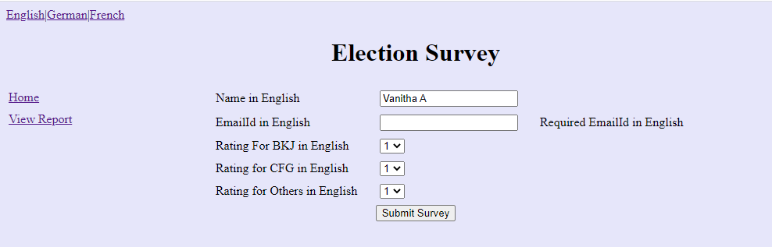

- Rule: Required valid emailId
- Message: Required valid EmailId in <<locale>>
  - If validation fails, UI should display the error message - “Required valid EmailId in <<locale>>”.

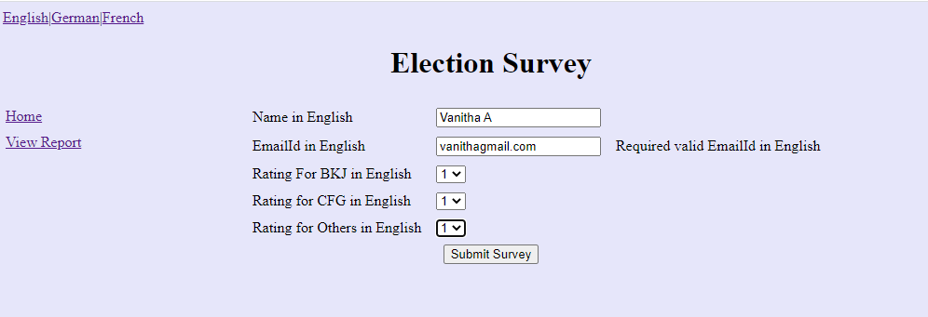

- Note: The messages have to be retrieved from the appropriate properties file. The properties file has been given as part of code skeleton. Do not change/modify the property file

2.2 Control Flow

- By giving the request /index from the browser (Eg: http://localhost:9095/index),the user should be redirected to the index.jsp
- Get input for name,emailId, ratingForBJK, ratingForCFG and ratingForOthers
- On clicking Submit Survey button, do the validation for UI components
- Check the emailId in the surveyList, If there is survey object present with same emailId then raise InvalidSurveyException. Else add the survey object into the list
- On clicking View Report, It should navigate to viewReport.jsp page

3.0 Component Specification

3.0.1 Controller

- The SurveyController should be configured via annotation as a Controller
SurveyController
Attribute Name | Attribute Type | Access Specifier | Constraints
service | SurveyService | private | Use annotation to autowire

Method Name | Method Argument name:type | Return type | RequestMapping URL & Request Method
showIndex |  | String | /index& GET
showPage | modelAttribute “survey”: Survey | String | /showPage& GET
submitSurvey | modelAttribute “survey”: Survey, result:BindingResult, model:ModelMap | String | /submitSurvey&GET
viewReport | modelAttribute “survey”: Survey, model:ModelMap | String | /viewReport&GET
exceptionHandler | Exception | ModelAndView | Use annotation to handle the user defined Exception

- SurveyService class should be autowired inside the Controller via annotations

3.0.2 Service
- SurveyService class should be configured via annotation as Service
SurveyService
Attribute Name | Attribute Type | Access Specifier | Constraints
surveyList | ArrayList< Survey > | private

Method Name | Method Argument name:type | Return type | Responsibilities
submitSurvey | “survey”: Survey | boolean | Check the emailId and raise InvalidSurveyException when Survey object present in surveyList with same emailId
viewReport |  | Survey | Calculate the average for the ratingForBKJ, ratingForCFG, and ratingForOthers, set the values to the Survey object, and return the Survey object.

3.0.3 Model

Class(Model) | Property | Methods
Survey | name:String  emailId:String  ratingForBKJ: float  ratingForCFG : float  ratingForOthers: float | //getters and setters are provided

- Include the needed annotations inside the Survey class for validations already mentioned. The error messages should be retrieved from the properties file

3.0.4 Internationalization
- Override the methods in InternationalizationConfig class provided as part of the code skeleton to support Internationalization.
- Note: For the LocaleChangeInterceptor, to internationalize the page based on the new Locale, use the parameter "language".
- Hint: Request from the UI (showPage.jsp) for all the three hyperlinks have language parameter added to a request. Do not modify/change the hyper link /the values already provided as part of the code skeleton in the showPage.jsp

3.1 Request Mapping Tasks

/index | Redirect the user to index.jsp
/submitSurvey | Redirect the user to showPage.jsp. Should invoke submitSurvey of the Controller after submitting all the valid Survey details from showPage.jsp, which in turn should invoke the submitSurvey of the SurveyService and if there are validation errors it should be redirected to showPage.jsp page. If there is an exception then it should redirect to exceptionPage.jsp
/viewReport | .Should invoke viewReport of the Controller which in turn should invoke the viewReport of the SurveyService.

4.0 Overall Design Constraints
- Implement the code using the best design standards.
- Use Internationalization for all the labels and messages in the submit survey page.
- showPage should support Internationalization for three languages English, German and French. The error messages and the labels should be displayed from the properties file depending on the locale. The properties file is already provided as part of the code skeleton.
- Spring Validator should be used for all the Validations. Use only annotation for performing the validations.
- ElectionSurveyApplication which is the main class, is already provided as part of the code skeleton. Include only the required annotations to auto scan the Controller, Service classes.
- Do not change the property name given in the application.properties files, you can change the value and you can include additional property if needed.
- In the pom.xml you are provided with all the dependencies needed for developing the application.
- You will not be evaluated based on the UI design (layout, color, formatting, etc.). You are free to have a basic UI with all the required UI components (input fields, buttons, labels, etc.). Expected components with the id alone should be designed as per the requirement.
- Adhere to the design specifications mentioned in the case study.
- Do not change or delete the class/method names or return types which are provided to you as a part of the base code skeleton.
- Also do not change the name or id of the HTML component which are provided to you as a part of the base code skeleton.
- Please make sure that your code does not have any compilation errors while submitting your case study solution.

